**Deliverable 2**

# **Summary of the Project Information:**

## Group member names and responsibilities

/*

**NOTE**: We have decided to follow a democratic approach where all of us take the lead (and act as Systems Analyst) depending upon our strongest qualities

*/

## Chris Zhao

* **Roles:**
  + Brainstormer / creative thinker
  + Web organizer
  + Note taker
* **Activities:**
  + Research into other Food Bank Systems
  + Website Management
  + Script Creation for Pitch
  + Recorded Meeting Time and Duration
  + Documenting interview contents
  + Note Taker during Interview

## Devroop Banerjee

* **Roles:**
  + Information gatherer
  + Brainstormer
  + Communications manager
  + Food Bank Volunteer and User
* **Activities:**
  + Delivered Surveys
  + Job Shadowing
  + Interview
  + Public Speaking
  + DFD, Use Case Diagram, Context Diagram Creation
  + Made Presentation Slides

## Hongyu Dai

* **Roles:**
  + Boosts team morale
  + Keeps team in check
  + Brainstormer
  + Web organizer
* **Activities:**
  + Research into other Food Bank Systems
  + Website Creation and Management
  + Public Speaking
  + Job Shadowing
  + Gathering System Functional and Nonfunctional Requirement
  + Use Case Specification Creation

## Tariq Chatur

* **Roles:**
  + Handles most of the written documentation
  + Public Speaker
  + Graphic design and powerpoints
* **Activities:**
  + Interview
  + Survey Creation
  + DFD, Context Diagram, Use Case Diagram, and Gantt Chart Creation
  + Recorded Meeting Times and Duration
  + Made Presentation Slides
  + Deliverable 1 & 2 Creation

## Xuyao Qin

* **Roles:**
  + Supports team members
  + Improves team spirit
  + All-rounder
* **Activities:**
  + Documented Interviews
  + Scheduled Meetings
  + Researched Possible Food Bank Systems
  + Documents proofreading/editing
  + Alternative solution Pros & Cons
  + Survey Data Analysis

## Wanjin Yoo

* **Roles:**
  + Supports team members
  + Dedicated team member (all-rounder)
  + Brainstormer
* **Activities:**
  + Recorded Interview
  + Gantt chart creation
  + Food Bank Research
  + Use Case Specification Creation
  + Survey Creation & Data Analysis
  + Deliverable 1 & 2 creation

## Client Name & Organisation Type:

**Client name**:

The UVSS Food Bank and Free Store

* Alexandra, Food Bank Coordinator
* Josie, Food Bank Assistant Coordinator

**Information**:

A Non-profit Organisation located in the basement of the SUB, aiming to provide all UVic students with regular and reliable access to food staples and free household items.

* **System under study**
  + Food Bank, inventory tracking system.
* **Current State of System** 
  + Paper based, using an excel document format
  + Information is input by users
  + Donations of miscellaneous items are not tracked
  + For monthly and yearly Usage Data Analysis, information must be manually calculated
  + Tracks user information using Student numbers and names
  + Records how many items each user has taken.
* **System Advantages**
  + No need for training of Food Bank staff
  + Low cost, no need for maintenance
  + Provides security theatre through the recording of Student Numbers
  + Collects total food consumption and user interaction data
  + Can handle unexpected delivery schedules (eg. Volunteer was called at the food bank saying that the alumni and development office will collect and donate, food and clothing from around 60 people by mid-December)
* **System Disadvantages**
  + Data is unreliable because it is inputted by users
  + Data can be easily lost or destroyed due to it being paper based
  + Takes up user time
  + Collects information that is unnecessary and overly specific about each user

# **Analysis Report:**

## Final System Statement of Purpose:

* To track the Food Bank Inventory and interactions, and create a document that highlights usage over a period of time.

## Final System Context Diagram:

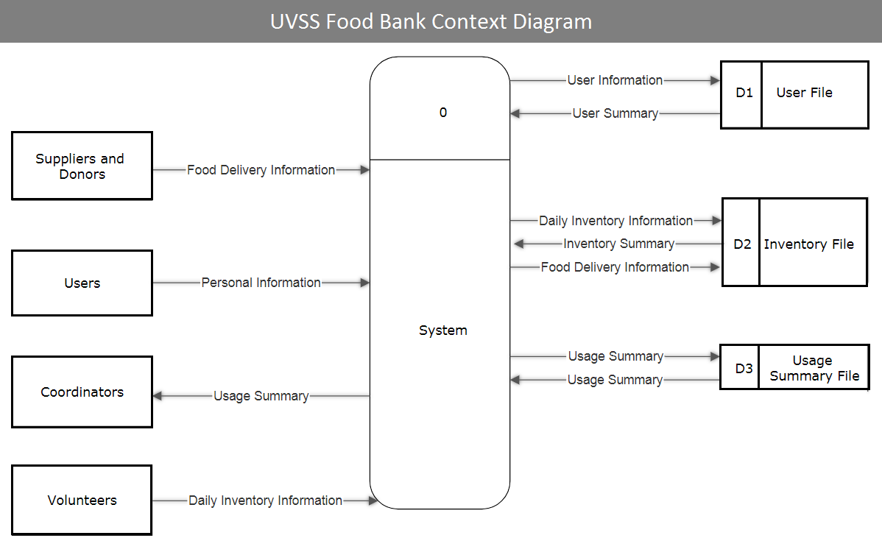

## System’s Requirements:

### Functional:

* Input Daily Inventory Information
* Input Delivery Information
* Input User Information
* Request Usage Summary

### Non-Functional:

* Easy to learn - Any university student should be able to understand how it works in 10 minutes
* Ease of data recovery - Data is stored on both disk and on UVic’s private email server
* Authentication - Only volunteers have access

### Risks & limitations:

* Limitations
  + Data has to be stored in a server inside of BC
  + Non profit organization; therefore, equipment must be cheap or free
  + Software malfunctions will be handled slowly if at all
* Risks
  + Potential High costs in equipment replacement
  + Lazy volunteers poorly record data
  + Software either is incomplete or buggy
  + All volunteers have access to data storage and authentication (could have been avoided if the coordinators were the first volunteers of the day, everyday or if the passwords were changed monthly)

### Proof of Client’s Approval of Deliverable 2:

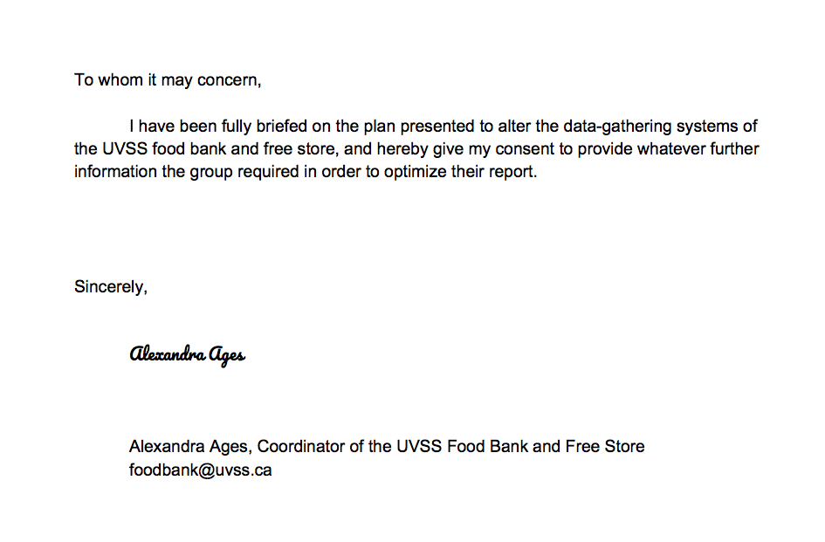

## Preliminary analysis for the alternative solutions:

What Initially led us to look for alternative solutions was the fact that Uvic’s data is not permitted to leave BC. Otherwise, our solution would have been much simpler and robust, using Google Sheets. Hence, we decided to look to other Food Banks in Victoria as sources of inspiration.

St. John the Divine Anglican Church/Mustard Seed Street Church & Food Bank, receives money from donations run by volunteers through the church and through canned goods donated to the Save on Food’s (Cook St).

Based on the team’s research, the following are the most widely accepted types of tracking methods where daily tracking is the more popular of the two. Although counterintuitive, the idea is to improve overall and in-the-long-run efficiency by giving the system room for some inaccuracy. Here are the pros and cons of real-time vs daily tracking systems.

### Real-time tracking systems:

#### Pros:

1. Immediate information updating

2. Detailed information about users

3. High data accuracy

#### Cons:

1. Expensive to maintain

2. Training required

3. More labor demanded

### Daily tracking systems:

#### Pros:

1. Easy to establish

2. Less training required

3. Easy to operate/maintain

4. Scheduled updating

#### Cons:

1. Less detailed information about users

2. Third party donation must be recorded manually

## Approach To Find A Solution

The original design was based on real-time tracking which records detailed information such as the specific amount of food taken by each user. Since the stock information is updated immediately after each operation, it not only generates results instantly but also guarantees the accuracy of data. However, it requires more training and labour input because the volunteers are responsible for updating. After studying the requirements and objectives from our client, we discovered that the client only cares about the inventory information for each day. In other words, the amount food taken per user is not important. Because the data is inputted by volunteers and Food Bank users, the data itself is not reliable. Making a real-time tracking system not practical. To make the system more simple and feasible, we switch our design to daily tracking. In the new disign, volunteers only record users’ student number for each visit and the coordinator checks the remaining inventory every morning to update the stock information.

# **Appendix:**

## Analysis diagrams implemented:

### 1. Use case diagram:

## 

### Use case specification:

#### Case 1:

**Name**: Input daily inventory

**Actors:** Volunteers

**Preconditions:**  Weekday morning

**Steps:**

1 . Execute the system.

2. Input the items that are available for the day.

**Success condition:** Daily inventory is successfully updated

**Alternative path:** None.

#### Case 2:

**Name**: Input delivery information.

**Actors:** Volunteers

**Preconditions:** Weekday morning,must have received delivery/invoice.

**Steps:**

1. Copy the invoice into the system/manually count

**Success condition:** The record has been confirmed and updated rightly .

**Alternative path:** None.

#### Case 3:

**Name** : Input user information

**Actors:** Volunteers

**Preconditions:** Users must have V(student) number.  
 **Steps:**

1. The users provide their V(student) number.

2. Volunteer input the number provided.

**Success condition:** User information has been updated.

**Alternative path:** None

#### Case 4:

**Name :** Request usage summary

**Actors:**  Coordinators

**Preconditions:** The system must have been used before.  
 **Steps:**

1. Coordinator requests the summary.

2. The system displays the summary

**Success condition:** Usage summary is displayed.

**Alternative path:** None

## 2. Level 0 Data Flow diagram:

**Opportunities – what skills / abilities can the team bring to solving the problem**

As broke 3rd and 4th year computer science students, we have the reason, passion, and knowledge to make the food bank’s system better. Besides, grades and GPA are huge motivators when it comes to bringing the team together. Finally, one of our members is a volunteer at the food bank and he has previous knowledge of the system. Apart from that, the team has a good working relationship with the coordinators.

**Brief project plan and gantt chart showing what has been done and what will be done during the remainder of the term**

So far, we have:

* Updated the website every week
* Did a sufficient amount of background research by interviewing the coordinator and coordinator assistant of the food bank
* Brief discussion about the solution
* Made the RFP/Pitch
* Made the survey for the food bank staff and users

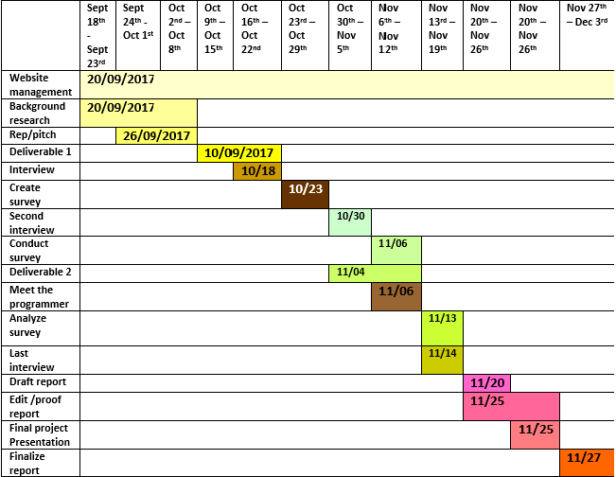

What we intend to do -

* Observe other food bank systems
* Analyze the data gathered from survey/ethnography
* Discuss our options with the food bank and the programmer
* Start preparing a rough draft, continue working on it till the end of the semester
* Draft report, final presentation and final report
* Two more official interviews to be conducted (Team is in contact with coordinators everyday for minor queries)
* Weekly team meetings until the end of the term
* Further online collaboration
* Performance evaluation from the clients